SIF Framework (.NET)

Version 6.0.0

Environment Provider Administration

**Author:** , SIF Solutions Architect

**Revision:** 1.0

**Published:** Aug 2022

Copyright © 2022, Systemic Pty Ltd

Table of Contents

1. Introduction 3

2. Environment Provider purpose 3

3. Environment Provider configuration 3

3.1. Defining an Environment 3

3.2. Using an Environment 4

# Introduction

This document provides an overview of Environment Providers and the management of Environment data for Service Consumer and Object Service Provider interaction. The information in this document is specific to the Environment Provider included with the SIF Framework when used in a DIRECT environment. It does not cover Environment Providers used by SIF Brokers in a BROKERED environment.

# Environment Provider purpose

An Environment Provider manages the interaction between Consumers and Providers by:

1. Specifying the endpoints for services provided in both DIRECT and BROKERED environments.
2. Specifying the data and service permissions of Consumers and Providers in any interaction.
3. Managing the session token for Consumers and Providers in any interaction with the Environment Provider.

All communication between Consumers and Providers passes through an Environment Provider to ensure connection to the appropriate services and to control data access.

In relation to session tokens, the Environment Provider included with the SIF Framework was developed to only work in a DIRECT environment and will only manage session tokens for Consumers. With this DIRECT environment, Object Service Providers do not require session tokens (as they are considered part of the same executing session as the Environment Provider).

# Environment Provider configuration

Before a Consumer and Provider can interact (via the Environment Provider), an Environment must be created to specify service endpoints, Consumer (data and service) permissions and Provider (data and service) permissions. Data and service permissions for Consumers and Providers are defined using Access Control Lists (ACLs) for the resources being connected to.

Once an Environment has been specified, a Consumer or Provider is able to register to that Environment through the Environment Provider. This registration process manages the session token (associated with the Environment) for the purposes of authorisation and authentication.

## Defining an Environment

An Environment is a SIF Infrastructure model that contains definitions for service endpoints and ACLs for resources. For the SIF Framework, these Environment definitions are mapped to appropriate database tables using an Object-Relational Mapping (ORM) tool such as Entity Framework Core.

The Sif.Framework.Demo.NetCore.Setup Project is used to populate the Environment Provider database (SifFrameworkDatabase) with a pre-defined Environment definition for the various demo projects. This Environment definition is stored as a “template” definition in the ENVIRONMENT_REGISTER table (along with associated tables).

By default, the set-up project uses a SQL Server LocalDB database (created in the Users folder). SQL Server Object Explorer can be used to inspect the database.

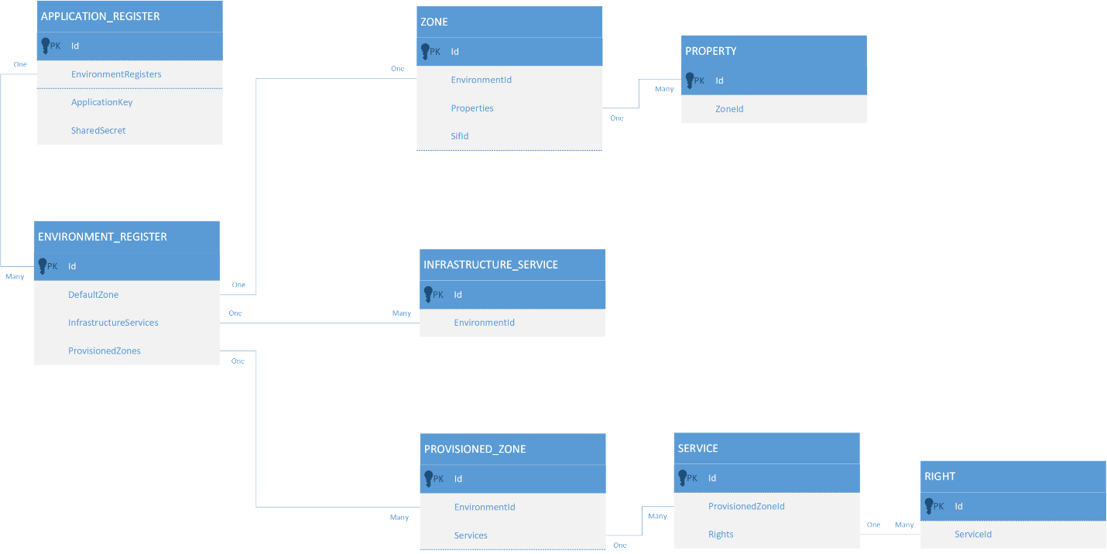

Figure 1: Environment register (template) table

The Environment definitions are located as XML files in the *Data files* folder of the set-up project. The *EnvironmentResponse.xml* file specifies the service endpoints and ACLs, and this information is mapped to the ENVIRONMENT_REGISTER table. The *EnvironmentRequest.xml* file specifies the Consumer details to associate with the service endpoints and ACLs, and this information is mapped to the APPLICATION_REGISTER table. A Consumer is considered a calling “application” in this scenario. The combination of these files effectively defines an Environment definition for a Consumer.

## Using an Environment

When a Consumer registers with an Environment Provider for the first time, an entry is created in the ENVIRONMENT table (along with the session token) and is associated with the corresponding ENVIRONMENT_REGISTER entry. In addition, an entry in the APPLICATION_INFO table is also added containing

Figure 2: Database tables that map directly to an Environment model